a ***GIT***

***How to push the code from Local machine to GIT***

1. Create a repo in github.com by signing in and note down the url which is similar to this



1. Open the command prompt from the project root location and inform git who u are using name and email address with the following commands
2. ***git config --global user.name “Ragavendran”***
3. ***git config --global user.email “***[***raghavdce@gmail.com***](mailto:raghavdce@gmail.com)***”***
4. To push your codes to git basically you need to create a folder in your root project directory to inform GIT, that this is place you need to pick up all the code and to do that use

---> ***git init***

Note: Post this is successful, a .git (hiddedn folder) will get created automatically.

1. The Git hub will not directly take all the codes unless it is commited. So, the flow goes like this local folder 🡪 staging (first level of commit) 🡪 Commit (final level of commit) 🡪 GitHub
2. To push codes to staging area use

***git add \**** // where * denotes all file. If you want to push a specific file mention the file name instead of *

1. Use the following command to get to know the list of files which are ready to be commited

***git status***

1. To push codes from staging area to commit area use

***git commit –m “my first commit”***

1. In order to push the code from the local machine to git hub, we need to make a connection between the two entity and to achieve that use

***git remote add origin [git repo url as shown in point 1 without braces]***

1. So now to push codes use the following command

***git push origin master*** //where origin is remote and master is branch

1. For the first time, it will ask the user to provide the git login credentials

***How to Clone / pull the code from GIT to Local machine***

1. Cloning will be done when you freshly download the code for the very first time from GIT to local machine. Post that we will use PULL to get updated part of the project rather than entire project. So, in order to clone a repo, open command prompt from a place where you want to download the project and please use

**git clone [url of git repo]**

Note: It might ask the credentials

1. To get the latest changes made by other user, use the following command

**git pull origin master**

***How to create Branch and deal with it***

1. To create a new branch and switch to it from Master branch in Git, use the following command

**git checkout –b [branch name without braces]**

Note: the same will be reflected in eclipse if you click the project name or Refresh it

1. To check the branch name that we are currently in use

**git branch**

Note: The current branch name will starts with * symbol

1. To switch between the branches

**git checkout branchname**

1. To pull a particular branch into your machine then use

**git pull origin branchname**

1. To push changes / updates to a branch then use

**git push origin branchname**

**Note: This will create a pull request**

1. To delete a particular branch from repo

**git branch –d branchname**

1. To push all the codes that are updated in branch to master, first user needs to switch to master and then merge the code

**git checkout master**

**git pull origin master**

**git merge branchname**

***How to create Branch and deal with it***

Assume a situation where in User A has updated some code / added a new file with some content (say 10 lines) and pushed it to master. Now user A is asking user B to help on completing the new added file. So, User B takes a copy of master by creating a new branch and started working there. In the mean while user A has deleted two lines or added two more lines without informing user B. Without knowing this, user B has done his part and tries to merge the master into his local again and this time he will face merge conflict and eclipse will show you with “<<<<<Head” and “>>>>> master” where it finds the difference. So now user B must manually check with User A and make the changes in new file and save it and commit it and then merge it to avoid merge conflict

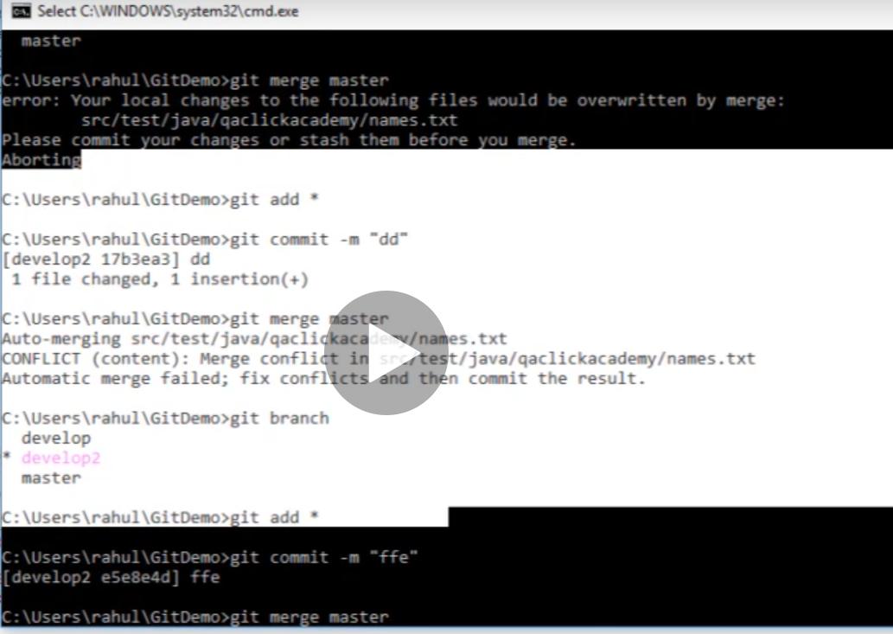

Git generally asks the user to enter credentials everytime when we try to perform push to the master. To overcome it use the following command

**Git config --global credential.helper manager**

**Git clone 🡪 it fetches a brand new copy from git hub repository**

**Git pull 🡪 it will pull only the changes that has happened and not the complete repo**

Difference between git add * and git add .

Git add * 🡪 moves all files to the staging area irrespective of changes made to the existing file or not

Git add . -> moves only the files that has changes to the staging area.

Git branch -a -> to list all the branches in the current repository

**Git pull vs git fetch**

Git pull 🡪 this command is used to pull the latest changes compared to your working directory and download all of them into your working directory.

Git fetch 🡪 this command is like a notification command i.e., it will check whether are there any changes between local and remote directory and list them. In order to get them into your working directory the user has to perform git merge command.

**Trigger build in Jenkins based on git commit**

In Jenkins 🡪 Build Trigger 🡪 Select GitHub hook trigger for GITScm polling 🡪 Save

Git hub 🡪 project location 🡪 setting 🡪 webhooks on the left pan 🡪 Add Webhook 🡪 set

Payload URl 🡪 Jenkins url with port number 🡪 <https://localhost:8080/github-webhooks/>

Content-type = application/json

Which event would like this webhhok to trigger 🡪 just the push event

Select Active checkbox

Click add webhook

